**Artificial Neural Network (ANN)**

Presented to

Prof. Farzad Amirjavid, PhD in CS

Artificial Intelligence in Canadian Perspective

Lambton College

Prepared by

Karthikeyan Mohan

18th April 2021

**Table of Contents**

A. Artificial neuron 1

B. Activation function 2

C. Artificial neural net (ANN) 3

D. ANN strength 3

E. ANN Limitations 4

F. Perceptron 5

G. Feedforward Network 6

# Artificial neuron

An artificial neuron is a connection point in an artificial neural network. Artificial neural networks, like the human body's biological neural network, have a layered architecture. Eery network node (connection point) will method input and forward output to alternative nodes within the network.

In each artificial and biological architectures, the nodes are known as neurons, and therefore the connections are characterised by conjugation weights, that represent the importance of the connection.

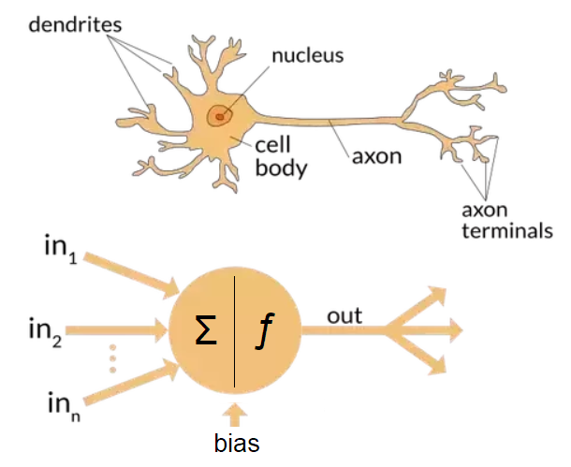

As new information is received and processed, the synaptic weights change, and this is often however learning occurs.

People have implemented model neurons in hardware as electronic circuits, often integrated on VLSI chips. Remember though that computers run much faster than brains - we can therefore run fairly large networks of simple model neurons as software simulations in reasonable time. This has obvious advantages over having to use special "neural" computer hardware.

# Activation function

An [activation function](https://en.wikipedia.org/wiki/Activation_function) in a neural network defines how the weighted sum of the input is transformed into an output from a node or nodes in a layer of the network.

Sometimes the activation function is called a *transfer function* If the output range of the activation function is limited, then it may be called a *squashing function*. Many activation functions are nonlinear and may be referred to as the *nonlinearity* in the layer or the network design.

**Types of activation functions:**

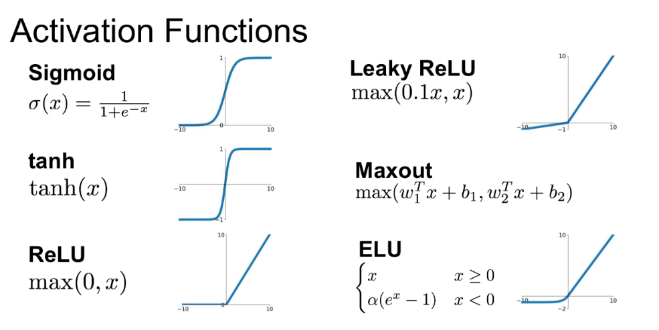

1. **Sigmoid Activation Function:**Sigmoid Function is one the special function in Deep Learning Field, thanks to its simplification during Back Propagation. As we can see in this image, it:

* Range from [0,1].
* Not Zero Centred.
* Have Exponential Operation

1. **Rectified Linear Unit Activation Function (ReLU):**ReLU is the most commonly used Activation Functions, because of its simplicity during backpropagation and its not computationally expensive.   
   It has following properties:

* It doesn’t Saturate.
* It converges faster than some other activation functions.

1. **ELU(Exponential Linear Units):**

ELU is also a variation of ReLU, with better value for x<0. It also have same properties as ReLU along with:

* No Dead ReLU Situation.
* Closer to Zero mean Outputs than Leaky ReLU.
* More Computation because of Exponential Function.

# Artificial neural net (ANN)

An Artificial Neural Network in the field of Artificial intelligence where it attempts to mimic the network of neurons makes up a human brain so that computers will have an option to understand things and make decisions in a human-like manner. The artificial neural network is designed by programming computers to behave simply like interconnected brain.

There are four different layers in ANN :

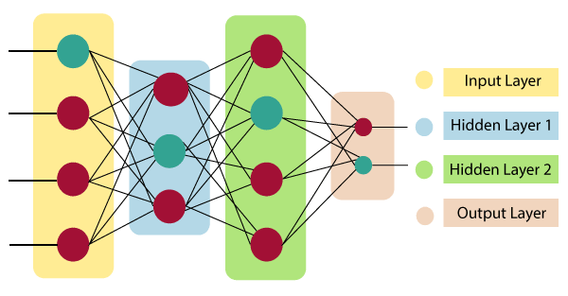

# ANN strength

**Parallel processing capability:**

Artificial neural networks have a numerical value that can perform more than one task simultaneously.

**Storing data on the entire network:**

Data that is used in traditional programming is stored on the whole network, not on a database. The disappearance of a couple of pieces of data in one place doesn't prevent the network from working.

**Capability to work with incomplete knowledge:**

After ANN training, the information may produce output even with inadequate data. The loss of performance here relies upon the significance of missing data.

**Having a memory distribution:**

For ANN is to be able to adapt, it is important to determine the examples and to encourage the network according to the desired output by demonstrating these examples to the network. The succession of the network is directly proportional to the chosen instances, and if the event can't appear to the network in all its aspects, it can produce false output.

**Having fault tolerance:**

Extortion of one or more cells of ANN does not prohibit it from generating output, and this feature makes the network fault-tolerance.

# ANN Limitations

**Assurance of proper network structure:**

There is no particular guideline for determining the structure of artificial neural networks. The appropriate network structure is accomplished through experience, trial, and error.

**Unrecognized behaviour of the network:**

It is the most significant issue of ANN. When ANN produces a testing solution, it does not provide insight concerning why and how. It decreases trust in the network.

**Hardware dependence:**

Artificial neural networks need processors with parallel processing power, as per their structure. Therefore, the realization of the equipment is dependent.

**Difficulty of showing the issue to the network:**

ANNs can work with numerical data. Problems must be converted into numerical values before being introduced to ANN. The presentation mechanism to be resolved here will directly impact the performance of the network. It relies on the user's abilities.

**The duration of the network is unknown:**

The network is reduced to a specific value of the error, and this value does not give us optimum results.

# Perceptron

A perceptron is a neural network unit (an artificial neuron) that does certain computations to detect features or business intelligence in the input data.

A Perceptron is an algorithm for supervised learning of binary classifiers. This algorithm enables neurons to learn and processes elements in the training set one at a time.

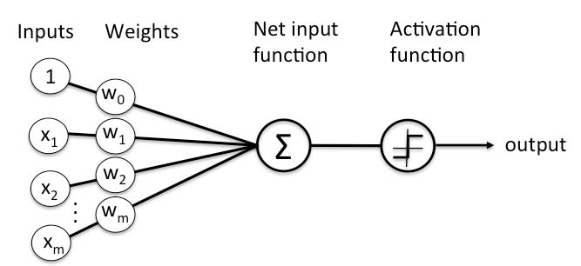

There are two types of Perceptrons:

* Single layer
* Multilayer

**Error in Perceptron**

In the Perceptron Learning Rule, the predicted output is compared with the known output. If it does not match, the error is propagated backward to allow weight adjustment to happen.

# Feedforward Network

A feedforward neural network is a biologically inspired classification algorithm. It consist of a (possibly large) number of simple neuron-like processing units, organized in layers.

Every unit in a layer is connected with all the units in the previous layer. These connections are not all equal: each connection may have a different strength or weight. The weights on these connections encode the knowledge of a network. Often the units in a neural network are also called nodes.

Data enters at the inputs and passes through the network, layer by layer, until it arrives at the outputs. During normal operation, that is when it acts as a classifier, there is no feedback between layers. This is why they are called feedforward neural networks.

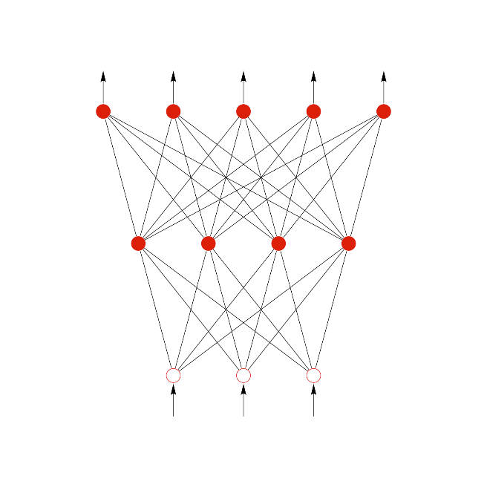

In the above figure we see an example of a 2-layered network with, from top to bottom: an output layer with 5 units, a hidden layer with 4 units, respectively. The network has 3 input units.